Designing an AI–EA Integration Blueprint

Adekunle Adeniji
Registration Number: 1378471
Module 4: Enterprise Architecture and Artificial Intelligence
Assignment #1: Designing an AI–EA Integration Blueprint
October 25, 2026

Part A word count: 1,181 (excluding headings, figure, and references)

Designing an AI–EA Integration Blueprint

Part A: Written Analysis
Artificial intelligence (AI) creates value only when it is connected to an enterprise’s strategy, data, platforms, and controls; enterprise architecture (EA) is the discipline that makes those connections. A recent systematic review links AI integration in EA to better decision-making, process optimization, and strategic alignment, but flags integration, data privacy, and ethics as unresolved problems (Abu Bakar et al., 2024). This analysis argues that EA should shape AI initiatives from the first use-case conversation rather than being consulted after a model is built. The Department of Defense Architecture Framework (DoDAF) serves as the reference framework.

Strategic Role of EA in AI
EA matters most at the start of an AI strategy, when the costliest decisions are made: which problems to automate, which data to trust, and which platforms to commit to. An EA practice brings a baseline of current capabilities, applications, data, and technology, and a target state tied to business goals (The Open Group, 2022). That baseline lets leaders rank AI use cases by value and readiness, not by enthusiasm for a tool.
EA mitigates three business challenges that often derail AI deployment:
- Poor data readiness. In a survey of 600 senior technology executives, 72% named data problems as the factor most likely to jeopardize their AI goals (MIT Technology Review Insights, 2022). In DoDAF, the conceptual, logical, and physical data models (DIV-1 to DIV-3) define a shared vocabulary, enforce relationship integrity, and specify the formats AI pipelines consume (U.S. Department of Defense [DoD], 2010). These views expose untrusted data before money is spent on models.
- Wasted and duplicated investment. Without a portfolio view, business units buy overlapping tools and fund pilots that never scale. EA ties each initiative to a capability and a funding decision, which stops low-value projects early.
- Integration and scaling failure. A model that works in a test environment often fails in production because its interfaces, security, and infrastructure were never designed. EA’s application and technology views define them in advance.
EA also aligns AI with organizational goals and ethics. Strategic alignment requires business strategy, IT strategy, and their infrastructures to fit together (Henderson & Venkatraman, 1993). EA makes this concrete through traceability: every model traces to a capability, a measurable outcome, and an accountable owner. The same traceability carries ethics: the DoD’s five AI principles (responsible, equitable, traceable, reliable, and governable) become enforceable only when written into architecture principles and standards (DoD, 2020a). However, a slow, document-heavy EA function can become a bottleneck that teams route around, so EA must work at the pace of AI delivery.

Design Considerations for AI Systems Within EA
A blueprint for scalable, explainable AI should describe the system as architecture layers, each with standards and an owner:
- Business layer. The capability served, the decision the AI informs or automates, its success measures, and the human oversight required.
- Data architecture. Authoritative sources, conceptual-to-physical data models, lineage from source to feature to prediction, quality rules, and privacy classification. The DoD Data Strategy goals of visible, accessible, understandable, linked, trustworthy, interoperable, and secure data make a practical checklist (DoD, 2020b).
- Model and application layer. A model registry recording version, intended use, training data, and known limits in model cards (Mitchell et al., 2019), plus standard application programming interfaces (APIs) for consuming predictions.
- Infrastructure readiness. Compute capacity; cloud or hybrid hosting; machine learning operations (MLOps) pipelines for automated testing, deployment, and retraining; and monitoring of drift, cost, and latency.
- Explainability. The explanation method for each audience and risk level, and where explanations are stored for audit. Explanations should be meaningful to their audience, accurate about how the system reached its output, and honest about its knowledge limits (Phillips et al., 2021).
- Risk and security controls. The risk tier, threats such as data poisoning and prompt injection, access control, and a fallback when the model fails.
Scalability comes from reuse: shared data products, platforms, and integration patterns stop each team from rebuilding the same plumbing. Explainability must be designed in at this stage; it is hard to add to an opaque model after deployment. The trade-off is real: the most accurate models are often the least interpretable, so the blueprint should state which risk tiers may use them.

Governance and Risk Management
EA frameworks institutionalize responsible AI by turning policy into repeatable architecture controls: principles, standards, review gates, and one inventory of AI assets. In its AI Risk Management Framework, the National Institute of Standards and Technology (2023) organizes this work into four functions (govern, map, measure, and manage) and treats governance as a cross-cutting duty rather than a final check. EA supplies the machinery for each function: the architecture repository maps where AI is used, review boards act as decision gates, and roadmaps manage remediation. ISO/IEC 42001 adds a certifiable management system for the same purpose (International Organization for Standardization, 2023).
Three risks show why this machinery is needed:
- Frankenstein models. This informal term describes AI solutions stitched together from separately sourced models, datasets, prompts, scripts, and APIs without an overall design or owner. Each part may work, but the whole behaves unpredictably and cannot be validated or explained. Sculley et al. (2015) describe the underlying technical debt: glue code, “pipeline jungles,” and entangled components where changing anything changes everything. EA prevents this with reference architectures, approved component catalogs, and lineage requirements.
- Model risk management. U.S. bank supervisors define model risk as the potential for adverse consequences from decisions based on incorrect or misused model outputs. They require sound development, independent validation, ongoing monitoring, and “effective challenge” by qualified reviewers (Board of Governors of the Federal Reserve System & Office of the Comptroller of the Currency, 2011). EA extends this discipline beyond banking by making model inventory and validation status part of every architecture review.
- Alignment gaps. These appear when AI initiatives drift from business strategy, when policy says one thing and deployed systems do another, or when a model optimizes a proxy metric instead of the intended outcome. EA closes them through traceability from strategy to model and through periodic compliance reviews.
Governance must also be proportionate: full review of a low-risk internal assistant wastes effort and pushes teams toward unsanctioned “shadow AI,” so control should scale with risk tier.

Recommendations
- Add an AI gate to the architecture review board (organizational). Staffed by EA, data, security, legal, and risk specialists, the gate reviews proposals at intake and before go-live, with depth set by risk tier.
- Build an enterprise AI inventory and reference architecture (technical). Register every model, dataset, and AI vendor service in the EA repository with its owner, purpose, lineage, validation status, and risk tier. Teams then assemble solutions from governed parts instead of building Frankenstein models.
- Treat data as a governed product (technical). Fund data owners to deliver certified data products with quality rules and lineage, using the DoDAF data views as the specification.
- Turn responsible-AI principles into testable standards (ethical). Express fairness, transparency, and accountability as checks such as bias tests, model cards, and human-override procedures, verified at each gate.
- Track value and retire models (organizational). Retire models that drift or no longer deliver the outcome they were approved for.

Part B: Visual Diagram
Figure 1 shows how EA and AI teams interact across the five stages of the AI lifecycle, and where governance decisions are made.
Figure 1
EA and AI Team Interaction Across the AI Lifecycle
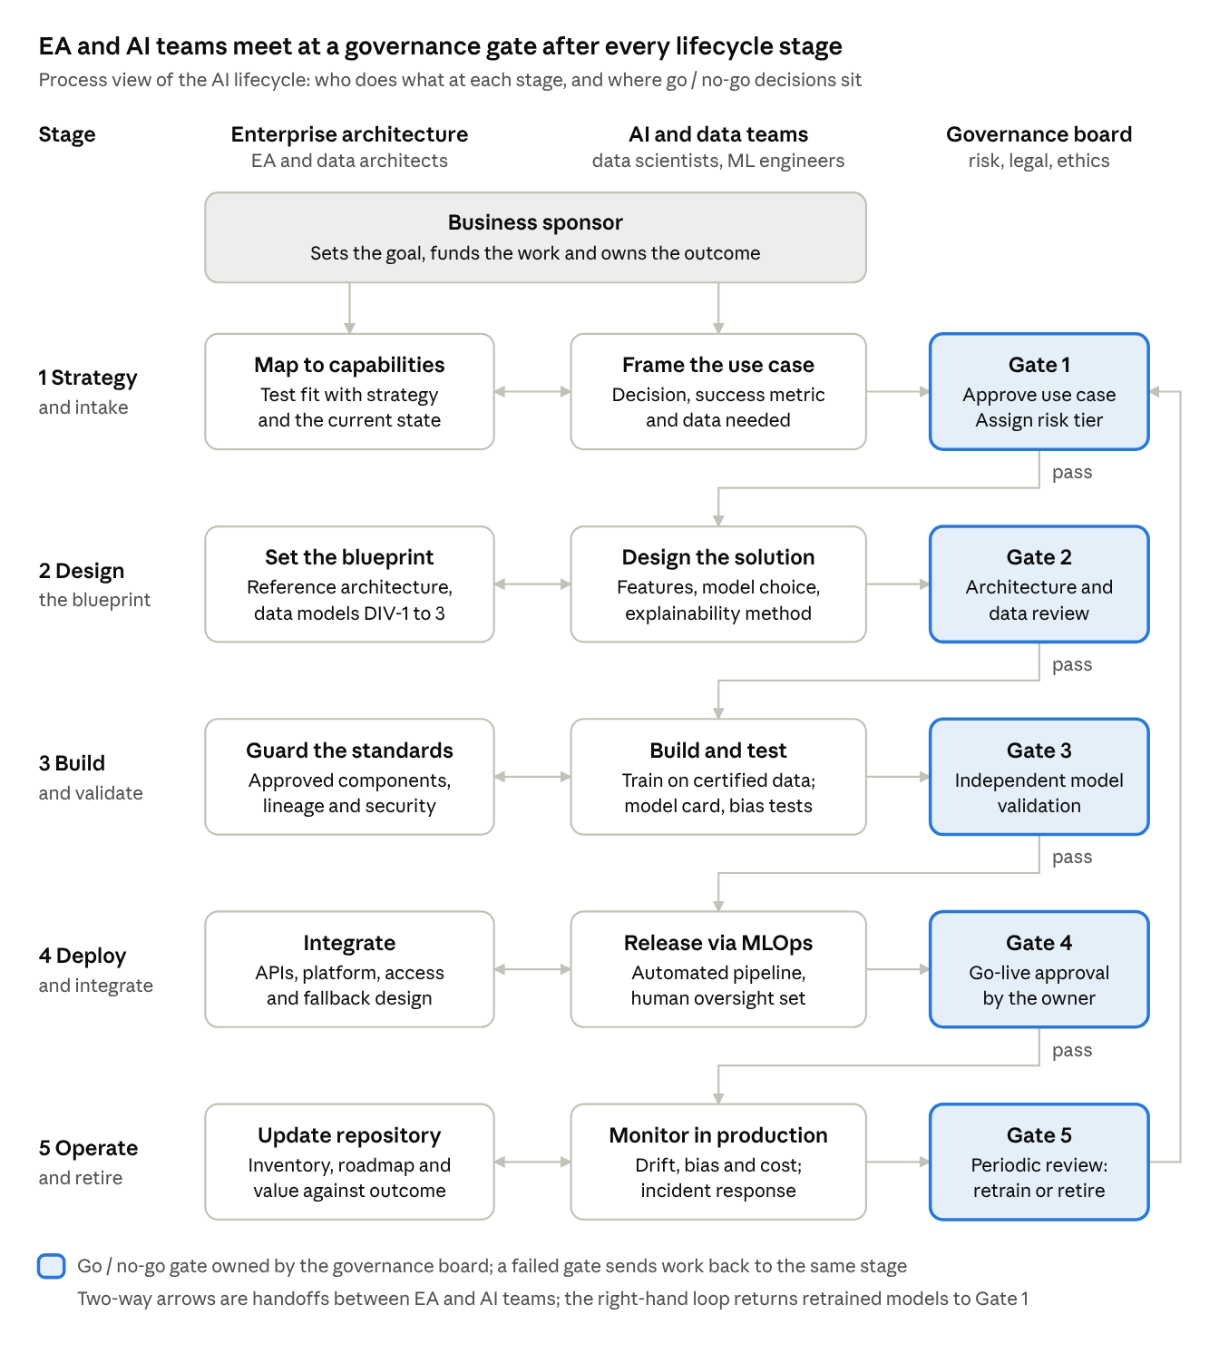
Note. Read each row left to right: EA and the AI team exchange artifacts, then the governance board decides at a gate before work moves to the next stage. Gate 5 can send a model back through Gate 1 for retraining, so the lifecycle continues after deployment instead of ending there.

References
Abu Bakar, N. A., Suib, A. H., Othman, A., Amdan, A. A., Abu Hassan, M. A., & Hussein, S. S. (2024). Artificial intelligence in enterprise architecture: Innovations, integration challenges, and ethics. In N. A. S. Abdullah, T. S. Hoon, et al. (Eds.), Proceedings of the International Conference on Innovation & Entrepreneurship in Computing, Engineering & Science Education (InvENT 2024) (Advances in Computer Science Research, Vol. 117). Atlantis Press. https://www.atlantis-press.com/article/126005579.pdf
Board of Governors of the Federal Reserve System, & Office of the Comptroller of the Currency. (2011). Supervisory guidance on model risk management (SR Letter 11-7). https://www.federalreserve.gov/supervisionreg/srletters/sr1107.htm
Henderson, J. C., & Venkatraman, N. (1993). Strategic alignment: Leveraging information technology for transforming organizations. IBM Systems Journal, 32(1), 4–16.
International Organization for Standardization. (2023). Information technology — Artificial intelligence — Management system (ISO/IEC Standard No. 42001:2023). https://www.iso.org/standard/81230.html
MIT Technology Review Insights. (2022). CIO vision 2025: Bridging the gap between BI and AI [Report sponsored by Databricks]. https://www.databricks.com/wp-content/uploads/2022/09/cio-vision-2025-final.pdf
Mitchell, M., Wu, S., Zaldivar, A., Barnes, P., Vasserman, L., Hutchinson, B., Spitzer, E., Raji, I. D., & Gebru, T. (2019). Model cards for model reporting. In Proceedings of the Conference on Fairness, Accountability, and Transparency (pp. 220–229). Association for Computing Machinery. https://doi.org/10.1145/3287560.3287596
National Institute of Standards and Technology. (2023). Artificial intelligence risk management framework (AI RMF 1.0) (NIST AI 100-1). U.S. Department of Commerce. https://doi.org/10.6028/NIST.AI.100-1
The Open Group. (2022). The TOGAF standard (10th ed.). https://www.opengroup.org/togaf
Phillips, P. J., Hahn, C. A., Fontana, P. C., Yates, A. N., Greene, K., Broniatowski, D. A., & Przybocki, M. A. (2021). Four principles of explainable artificial intelligence (NISTIR 8312). National Institute of Standards and Technology. https://doi.org/10.6028/NIST.IR.8312
Sculley, D., Holt, G., Golovin, D., Davydov, E., Phillips, T., Ebner, D., Chaudhary, V., Young, M., Crespo, J.-F., & Dennison, D. (2015). Hidden technical debt in machine learning systems. Advances in Neural Information Processing Systems, 28, 2503–2511. https://proceedings.neurips.cc/paper/2015/file/86df7dcfd896fcaf2674f757a2463eba-Paper.pdf
U.S. Department of Defense. (2010). The DoDAF architecture framework version 2.02. DoD Chief Information Officer. https://dodcio.defense.gov/Library/DoD-Architecture-Framework/
U.S. Department of Defense. (2020a, February 24). DOD adopts ethical principles for artificial intelligence [Press release]. https://www.defense.gov/News/Releases/Release/Article/2091996/dod-adopts-ethical-principles-for-artificial-intelligence/
U.S. Department of Defense. (2020b). DoD data strategy. https://media.defense.gov/2020/Oct/08/2002514180/-1/-1/0/DOD-DATA-STRATEGY.PDF

